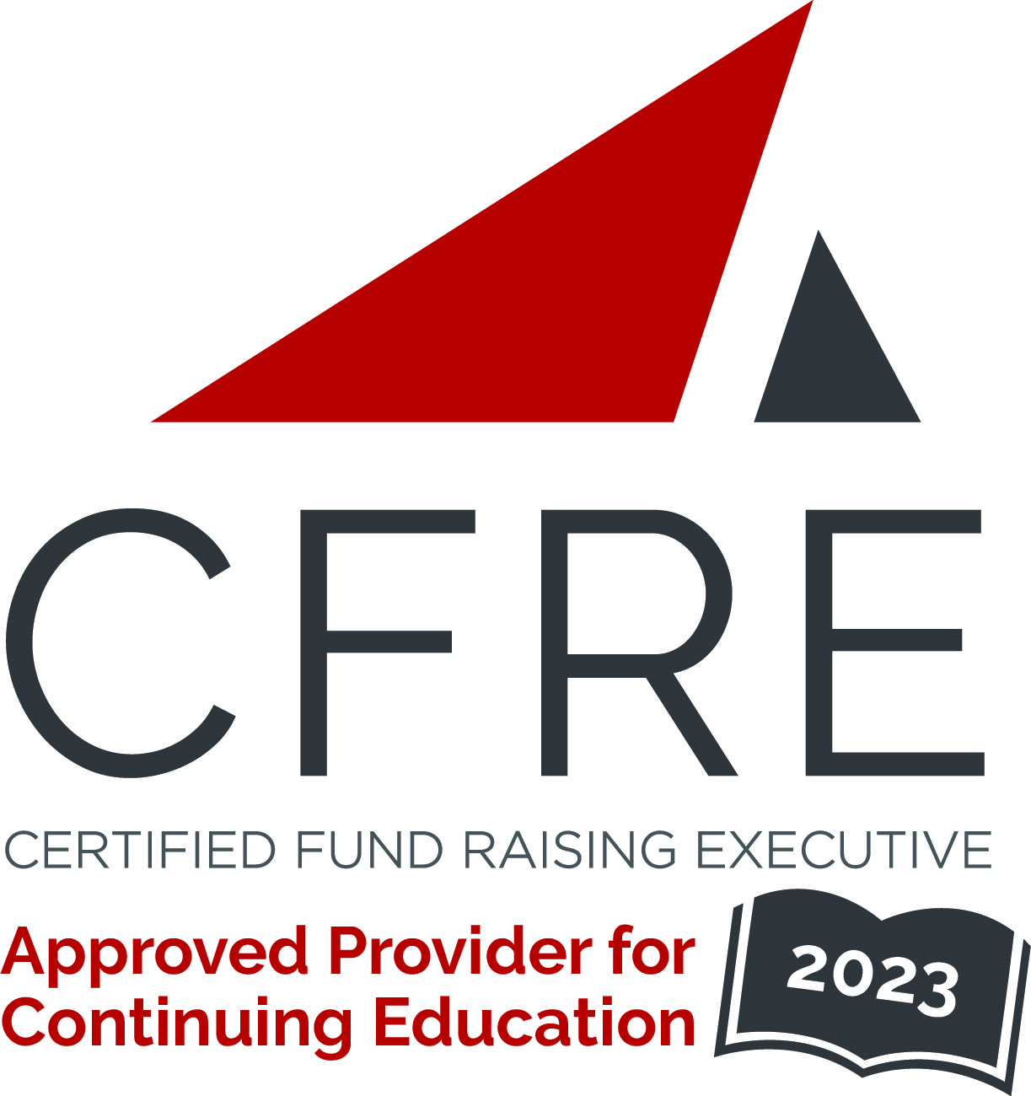  CFRE International has developed this form as a way for you to quickly track (and keep in your files!) the continuing education sessions you have attended. Simply check the boxes next to the sessions you attended. At the end of the conference, add up the total number of hours. Keep this sheet and you will be ready to complete your application form. All of the session slots listed are eligible for continuing education points on your CFRE application for initial certification and/or recertification. Sessions not listed here are not eligible for points. |  | CONTINUING EDUCATION POINTS TRACKER

Activity Organizer: - AFP Greater Madison Chapter
Title of Activity: - Fundraising Day Wisconsin 2023
Names of Presenter(s): - Various
Dates and Location: - 20 June, 2023 – Madison, WI USA

Date: 20 June, 2023
Session 1: 8:30am – 9:30am (1 pt)
- Resisting Work: Laziness Does Not Exist

Date: 20 June, 2023
Session 2: 10:00am – 11:00am (1 pt)
- Getting Your Organization Grant Ready
- Invisible Lines of Connection – Getting to the Ask without Asking
- Creating Meaningful Connections in an Overconnected World
- Growing a Planned Giving Program at any Stage
- Pushing Back: Rebuilding a More Equitable Nonprofit Sector

Date: 20 June, 2023
Session 3: 11:15am – 12:15pm (1 pt)
- Getting Your Organization Grant Ready
- Invisible Lines of Connection – Getting to the Ask without Asking
- Creating Meaningful Connections in an Overconnected World
- Pursuing Your CFRE – What You Need to Know
- Understand Your Human Design to Hit Your Career Goals

Date: 20 June, 2023
Session 4: 1:45pm – 2:45pm (1 pt)
- Getting Your Organization Grant Ready
- Invisible Lines of Connection – Getting to the Ask without Asking
- Creating Meaningful Connections in an Overconnected World
- Growing a Planned Giving Program at any Stage
- Understanding Your Human Design to Hit Your Career Goals

Total number of points attained: __________

